Bahria University,

Karachi Campus



LAB EXPERIMENT NO.

**07**

LIST OF TASKS

|  |  |
| --- | --- |
| TASK NO | OBJECTIVE |
| 1 | **Insert the following values to table Store** |
| 2 | **Add a new publisher whose name is Scotty and is in London UK** |
| 3 | **Update address of “Eric the Read Books” to “700 Catamaugus Ave”.** |
| 4 | **Increment all discounts by 10%.** |
| 5 | **Delete employee whose id is “VPA30890F”.** |
| 6 | **Delete all Authors whose first name starts with M** |
| 7 | **Create table My_Employees with following Columns:** |
| 8 | **Insert these 5 records in above mentioned table My_Employees.** |
| 9 | **Concatenate ID, first two letters of the FIRST_NAME and first seven characters of the LAST_NAME to produce the USERID in employee table** |
| 10 | **Change the LAST_NAME of employee 3 to ALPHA** |
| 11 | **Change the salary to 1000 for all employees with a SALARY less than 900.** |
| 12 | **Delete Betty Dancs from the My_Employees Table.** |

Submitted On:

**24-May-2022**

**Task 1: Insert the following values to table Stores**

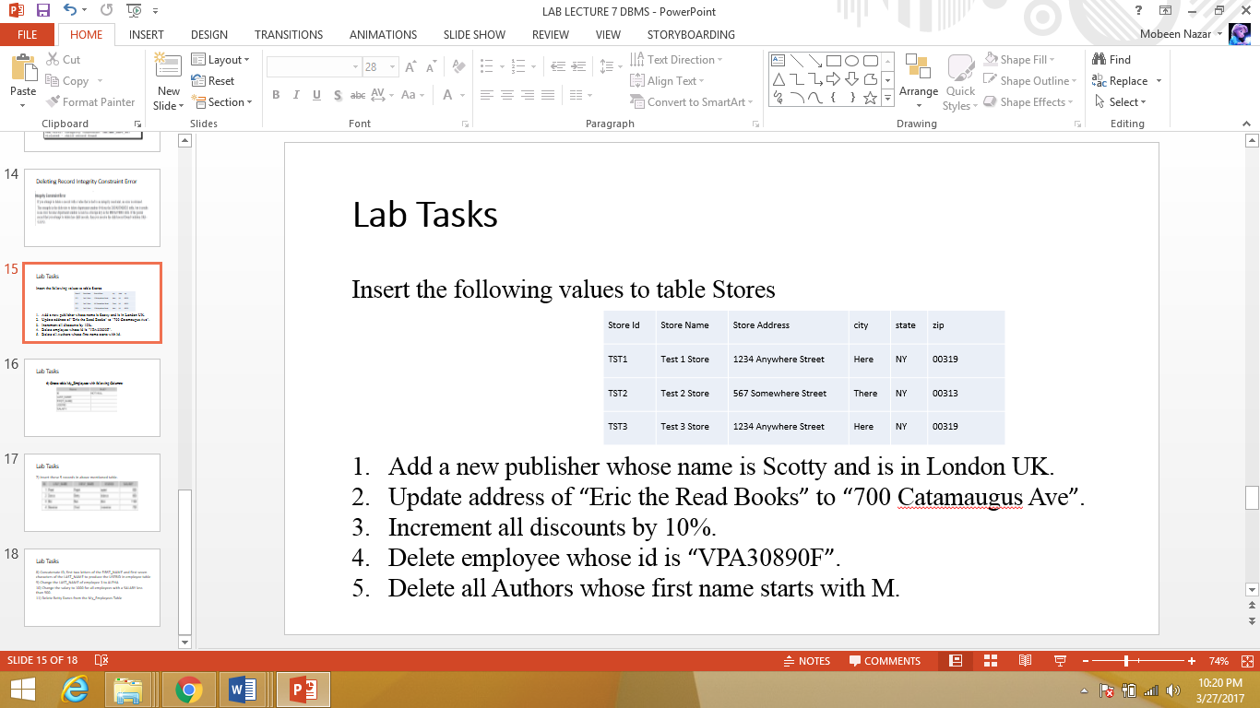  
 **Solution & Output**insert into Stores(Stor_id ,stor_name,stor_address,city,state,zip) values('TST1','Test 1 Store','1234 Anywhere Street','HERE','NY','00319');  
insert into Stores(Stor_id ,stor_name,stor_address,city,state,zip) values('TST2','Test 2 Store','567 Somewhere Street','There','NY','00313');  
insert into Stores(Stor_id ,stor_name,stor_address,city,state,zip) values('TST3','Test 3 Store','1234 Anywhere Street','HERE','NY','00319');

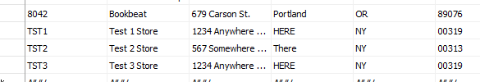

**Task 2: Add a new publisher whose name is Scotty and is in London UK.**

**Solution & Output**insert into Publishers(pub_id,pub_name,city,country) values ('9904','Scotty','London','UK')



**Task 3: Update address of “Eric the Read Books” to “700 Catamaugus Ave”.**

**Solution & Output**update stores set stor_address='700 Catamaugus Ave' where stor_name='Eric the Read Books'

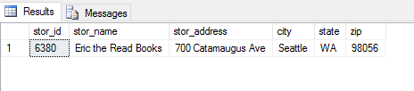

**Task 4: Increment all discounts by 10%.**

**Solution & Output**update discounts set discount= discount+((discount*10)/100)

**Before:**

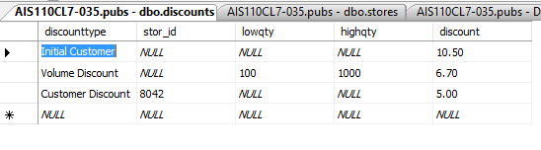

**After:**

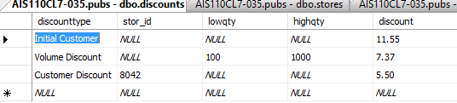

**Task 5: Delete employee whose id is “VPA30890F”.**

**Solution & Output**delete from Employee where emp_id='VPA30890F'

**Before:**

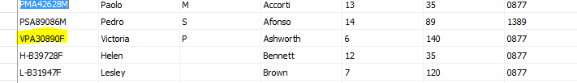

**After:**

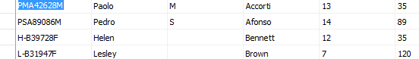

**Task 6: Delete all Authors whose first name starts with M.**

**Solution & Output**delete from authors where au_fname like 'M%'

*Cannot delete because it has some data, related to it, in titleauthor table.*



**Task 7: Create table My_Employees with following Columns:**

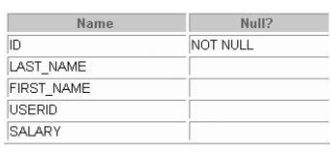

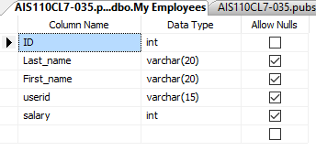**Solution & Output**

create table [My Employees] (

ID int not null,

Last_name varchar(20) ,

First_name varchar(20),

userid varchar(15),

salary int)

**Task 8: Insert these 5 records in above mentioned table My Employees.**

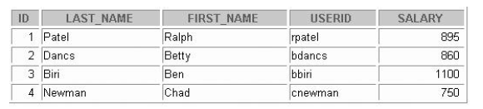

**Solution & Output**insert into [My Employees] values(1,'Patel','Ralph','rpatel',895)insert into [My Employees] values(2,'Dancs','Betty','bdancs',860)insert into [My Employees] values(3,'Biri','Ben','bbiri',1100)insert into [My Employees] values(4,'Newman','Chad','cnewman',750)

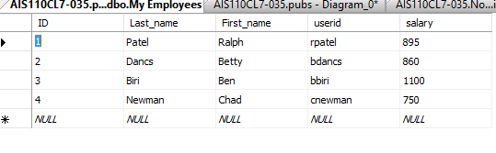

**Task 9: Concatenate ID, first two letters of the FIRST_NAME and first seven characters of the LAST_NAME to produce the USERID in employee table**

**Solution & Output**select convert(varchar,ID)+Substring(first_name,1,2)+substring(last_name,1,7) as Userid from [my employees]

**Task 10: Change the LAST_NAME of employee 3 to ALPHA**

**Solution & Output**update [My Employees] set last_name='Alpha' where id=3

**Task 11: Change the salary to 1000 for all employees with a SALARY less than 900.**

**Solution & Output**

update [My Employees] set salary=1000 where salary<900

**Task 12: Delete Betty Dancs from the My_Employees Table.**

**Solution & Output**delete from [My Employees] where first_name='Betty' and last_name='Dancs'

